Simple Data Entry Tutorial

This is a tutorial to create a simple data entry application. Licensing and error-handling will also be included although they are not necessary for proper functionality of the application. Later tutorials requiring the licensing and error handling will be built from this foundation. Note that code segments will be displayed in a different font with new code in bold.

- New Visual Basic project. Run Visual Basic and create a new Standard EXE project.

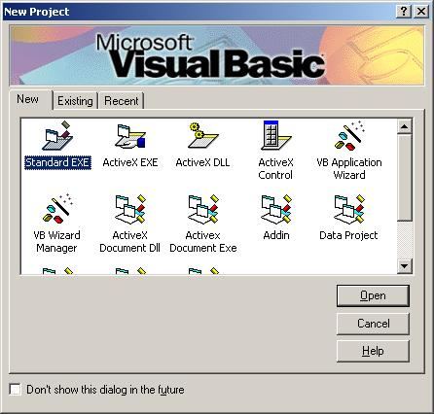

- Add controls to the form. Add the static text and edit boxes (txtField1 – txtField5). Add a button for Add to DB (cmdSubmit) to the form. Leave room at the top of the form for toolbar buttons to be added later. The form caption is “Manual Data Entry.”
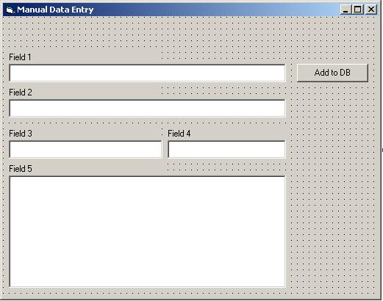

- Add code to the cmdSubmit_Click() handler. Also add code to clear and reset the text boxes.

Private Sub cmdSubmit_Click()
' TODO: Actually provide data to the remote database

' Show msgbox indicating success
MsgBox "Record added to database successfully!"

' Clear the text fields
ClearTextFields

' Reset current field back to Field1
txtField1.SetFocus
Exit Sub
End Sub

Private Sub ClearTextFields()
' Clear fields
txtField1 = ""
txtField2 = ""
txtField3 = ""
txtField4 = ""
txtField5 = ""
Exit Sub
End Sub

- The licensing and special error handling functionality added in this and the next three steps is not required for a simple data entry application but will be used in subsequent enhancements. Add the following UCLID COM objects to the collected References for the project.
- UCLID ComponentLM
- UCLID ExceptionMgmt

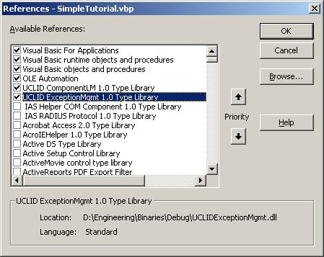

- Add the Input Funnel Licensing and Exception Handling modules to the project.

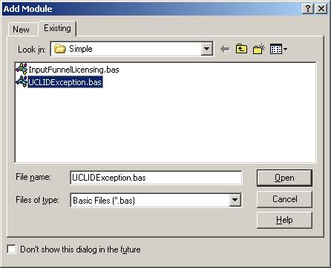

- Modify the following line in the Licensing module to reflect the appropriate license file name and passwords.

' Initialize licensing from specified LIC file
' NOTE: Passwords are specific to the individual LIC file
m_pLM.InitializeFromFile "LicenseFile.lic", 1, 2, 3, 4

- Add code to Form_Load() to initialize licensing and use the included error handling.

Private Sub Form_Load()
On Error GoTo errHandler

' Initialize licensing
InitInputFunnelLicense
Exit Sub

errHandler:
DisplayUCLIDException "ELI-Form_Load"
End Sub

- Save the form (frmMain.frm) and project (SimpleTutorial.vbp). Run the application and note that text can be manually added to each text box in any order. “Clicking the Add to DB” button displays a message box and clears the text boxes.

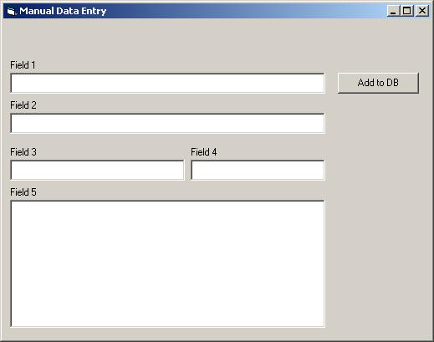

- Troubleshooting a licensing error. If the proper license file is not found or incorrect passwords are provided, the following message will be shown when starting the application. The application will still run because no UCLID components that require licensure are being used.

